Contact APP:

Homepage:

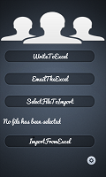

The ContactApp we can easily take backup your contacts from the phone. In Home Screen we have a option to save the contacts to Excel sheet. For creating a excel sheets we have a used jxl.jar as a library in our project. We can send the email with the excel sheet as attachment.

We can import the contacts from the ExcelSheet and create the contacts in our phone. Before Importing we have to select the .xls file by using the "selectFileToImport" button and we can import the contacts.

We have the Settings icon on the bottom of the screen. we can set the Triggering Time, Email id which are used while Contacts have to emailed(Weekly,daily or monthly).

SecondScreen:

When we have mail the contacts file, we have to enter the valid Email Id, Subject, Message

The Attachment is already attached. when we click on the send button, we will get the screen to choose Emailservice from existing. we have chosen the Gmail. The Gmail page is opened all the fields would be

populated.

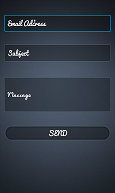

ThirdScreen:

In this Page we have Gmail App opened where all the fields are populated and the attachment file is already attached to mail..

only we have to click the send button to send the mail. When you select the Email instead of Gmail the Screen would be different.

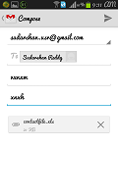

FilePicker:

When the contacts have to import we have to select the file from file chooser, we have to pick the .xls file from the "sdcard /ContactsApp/contactfile.xls" file.

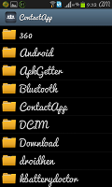

TriggeringService:

When we have to backup of contacts at regular time interval we have used alarm Manager service to send the conatctfile.xls file to email Id as attachment.

IN this Screen we have select TriggeringTime(Daily/Weekly/Monthly).

And Valid Email Id. When we click save button the alarm Manager service is started.

At Specified intervals alarmManager triggers the email service....The Gmail page would opened with all the fields populated automatically , Just we have to click the send button to send the mail with the attachment..

